**Leader Overview**

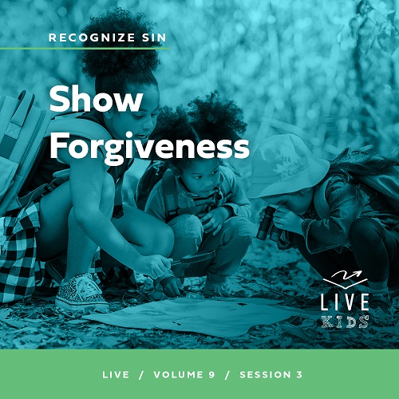

**Volume Overview**

**Recognize Sin**

*The Bible has a lot to say about sin and forgiveness. It acknowledges the deep brokenness of this world and our individual life. It is only by understanding the depth of human sin that we can understand the remarkable work of God’s forgiveness. Because of His forgiveness, we escape the eternal consequence of our sin and can rightly respond to the call to live a holy life. We learn to receive forgiveness, put off sin, and show forgiveness to those who have sinned against us. We learn to pursue holiness in the midst of the world’s brokenness.*

**Session Overview**

**Show Forgiveness**

*In this* **Live** *session, kids will discover that just as we have received forgiveness from God, we are called to show forgiveness to others. God showed us mercy when we didn’t deserve it, and in the same way, we should forgive others when they sin against us. Through this, we reflect God’s love to the world around us.*

**Bible Lesson**

The Parable of the Unmerciful Servant

[Matthew 18:21–35](https://ref.ly/logosref/Bible.Mt18.21-35)

**Faith Fact**

I can forgive others.

**Faith Verse**

[2 Corinthians 5:17](https://ref.ly/logosref/Bible.2Co5.17)(NLT)

Anyone who belongs to Christ has become a new person. The old life is gone; a new life has begun!

**Preparing for the Session**

**Leader Preparation Time: 20–25 Minutes**

|  |
| --- |
| ***You Will Need***  ***Large Group***   * *Bible* * *Worship songs (Song suggestions: “Free Indeed” Lyric Video by Planetshakers; “I Thank God” Lyric Video by Maverick City; “Trust” Lyric Video by Hillsong Young and Free; “Reckless Love” Lyric by Cory Asbury)* * *For groups not using a phone or tablet only, add:*   *• Projector or TV*  *• Laptop*  *•* ***Faith Fact Slide***  *•* ***Faith Verse Video*** *or* ***Slide***  *•* ***Bible Lesson Video***  *•* ***Teaching Point Slides 1–****3*  *•* ***Large******Group Teaching Time Sign****, three copies*  ***Small Group***   * *Small coins, one per kid* * *Cups, one per group* * *Bibles for kids in the group to share* * ***Small Group Faith Verse Review****, one set per team* * *Envelopes, one per team* * *Scissors* * *Optional: Smartphone with stopwatch* * ***Small Group Activity Page****, one per kid* * *Pencils or pens, one per kid* * *Crayons*   *To access session content and videos from a computer, visit:* [*BibleEngagementProject.com/downloads*](https://bibleengagementproject.com/downloads) |
| ***Getting Ready***  ***Large Group***   * *Download videos and slides if needed.* * *Select worship song(s) and have them ready to play.* * *Read the Bible Lesson Scripture to prepare for Teaching Time.* * *Print three copies of the* ***Large Group Teaching Time Sign****.*   ***Small Group***   * *Print the* ***Small Group Faith Verse Review****, one set per team.* * *Cut apart the page into ten random shapes to create ten puzzle pieces.* * *Place the puzzle pieces for each team in an envelope.* * *Print copies of the* ***Small Group Activity Page****, one per kid.*   *First time leading* Live *for Kids? Check out the* [*Facilitator Guide*](https://0b769b0ed3569ef9d18b-f88d8272f61086866d50d048b43ef630.ssl.cf2.rackcdn.com/sites/biblengagementproject/Listen_Facilitator_Guide.pdf)*.* |

**Large Group**

**30 Minutes**

*See what’s needed at the beginning of the session.*

**Introduction**

Hey, everybody! We’ll have an incredible time together as we learn about God and who He has called us to be. We’re learning how we can leave behind the old life we used to have to follow Jesus. New life in Him is so much better than what we used to know. Raise your hand if you want to experience this new life. *(Group response)*

When we follow Jesus, we’ll face some challenging situations that put our faith to the test. Today, we’ll talk about what we should do if someone else does something wrong to us. Has someone ever done something mean to you before? *(Group response)* I think every single person here can relate to that. Unfortunately, we have all faced unkindness or wrong done against us. Give me a thumbs up or a thumbs down to show how it feels when someone wrongs you. *(Group response)* Yeah, big thumbs down for me!

**Faith Fact**

I‘m so thankful for our Faith Fact as a reminder of how to respond when people hurt us. Our Faith Fact is **I can forgive others.**

• *Show the* ***Faith Fact Slide.***

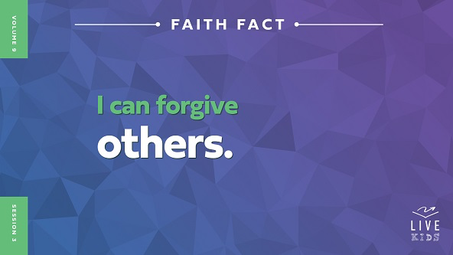

In our Bible story *(hold up the Bible)*, we’ll hear that Jesus told a story about a man who was forgiven, but then didn’t forgive someone else. Sometimes, even when we have been forgiven, it can be hard to forgive someone who has done something mean to us. With God’s help, we can show the love He has shown us to others. Point at yourself then to everyone in the room and say the Faith Fact. **I can forgive others.** One more time. **I can forgive others.** Well done!

**Game**

**Rock Paper Scissors Tournament**

Let’s have some fun with a Rock Paper Scissors tournament. Here’s how the game works. Everyone needs to stand up and find a partner. Hold one hand flat with your palm up and hold the other hand in a fist sitting on the flat hand. We’ll all say, “Rock, paper, scissors, go,” and bounce our fists down on each word. When we say “Go,” you’ll show your choice to your partner. Let’s practice the motions together *(demonstrate the motions)*. Most of you already know which item beats the others, but let’s review. Rock beats scissors, scissors beats paper, and paper beats rock.

If you are defeated, you’ll then become a big fan of the person who defeated you. You’ll follow them around and cheer them on. Anyone who won the first round will play in the second round, followed by their new fans. They’ll play someone else who is still in the game who also has a fan. Then, whoever wins round two will get two new fans. Basically, if someone beats you, then you and all your fans become their biggest fans. By the end of the game, we’ll have two people ready to compete with everyone else cheering them on as their fans. Let’s play!

• *Play the game. If partners tie on their rounds, let them continue to play as normal before starting the next round. There must be an elimination before going to the next round.*

• *Consider having the final round be the best two out of three.*

Good job, everyone! That was a lot of fun! How many of you liked having fans cheer for you? *(Group response)* How many of you liked it when you cheered for someone else? *(Group response)* Sometimes, especially if you’re competitive, in a game like this you can get upset about losing the round. Then, you don’t really want to cheer for someone who beat you. It’s best to just let that go so that you’ll have more fun. The same can be true about forgiveness. When we let go of the pain of how someone hurt us, we don’t have to bear the weight of it anymore. Let’s say the Faith Fact together as a reminder. **I can forgive others.**

**Worship**

When we worship God and sing about what He has done for us, we’re reminded of how God gave everything when Jesus came to live on earth. God sent Jesus because He loves us and wants to forgive us. Because He did that, we should do the same for others. Who is ready to worship God today? *(Group response)* One way to worship God is by singing. Let’s worship Him together.

• *Lead the kids in singing one or two praise songs. See suggestions at the beginning of the session.*

**Bible Lesson**

Thanks for worshipping with me, everyone! Worshipping God reminds us to live more like Jesus. Today, we’re learning that means forgiving others just like Jesus did even when they do wrong things against us. Remember our Faith Fact. **I can forgive others**. Let’s look at what the Bible says about this. Let’s pray to get started.

**Prayer**

|  |
| --- |
| *Dear God, thank You for forgiving all our sins when we ask You to. Help us learn how to forgive others even when they’ve really hurt us. Help us to learn how we can be more like You. In Jesus’ name. Amen.* |

**Video Intro**

Just before we look at the Bible story, let’s watch this video.

• *Play* ***Bible Lesson Video****.*

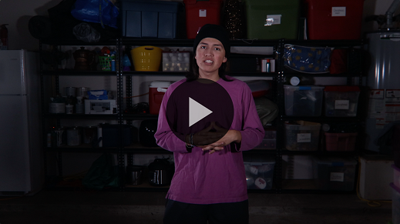

**Bible Story**

**The Parable of the Unmerciful Servant**

Have any of you ever been in a situation like Dash when someone did something that hurt you? *(Group response)* Dash did a great job showing us how the Bible helps us live for God. Let’s learn more about forgiving others as we have been forgiven. Grab your Bible or pull up a Bible app on your device. Turn to [Matthew 18:21–35](https://ref.ly/logosref/Bible.Mt18.21-35).

• *In order to keep Large Group time moving along, we recommend that the leader reads the Scripture portions aloud.*

• *Optional: Remind the kids to mark this place with their Bible bookmark so they can read it on their own at home.*

**Teaching Time**

|  |
| --- |
| ***You Will Need***   * ***Large Group Teaching Time Sign****, three copies*   ***Getting Ready***   * *Print three copies of the* ***Large Group Teaching Time Sign****.* |

Jesus loved to teach people through stories. The kind of stories He told were called parables, which are stories that are used to help teach a lesson. Jesus told these stories a lot, and people gathered to hear what He wanted to share with them.

Why do you think people wanted to follow Jesus and listen to His words so much? *(Allow responses.)* Great answers! Something about Jesus was really special. Some people could tell that and wanted to honor Him by giving their life to follow Him. I want to live like that. In our Bible story, Jesus shared a special parable with the people to teach them a lesson on forgiveness.

**1. Peter asked how many times he should forgive someone.**

• *Show the* ***Teaching Point 1 Slide.***

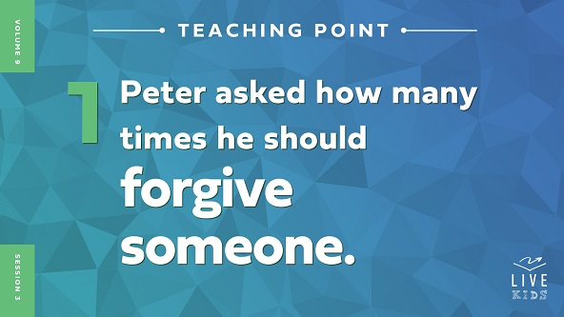

• *Read* [*Matthew 18:21–22*](https://ref.ly/logosref/Bible.Mt18.21-22)*.*

Peter, one of Jesus’ closest followers, asked Jesus a question. You might have wanted to ask Jesus the same question. How many times do I need to forgive someone? Peter asked if seven times would be enough. In those days, some religious leaders taught that the common limit for forgiving someone was three times.

Peter thought his answer was above and beyond what was required. He might have been feeling pretty good about that, but Jesus didn’t stop at seven times. Raise your hand if you know how many times Jesus said to forgive. *(Group response)* Jesus told him to forgive 490 times!

Now, Jesus wasn’t saying that anything over 490 times was not allowed. He also wasn’t telling Peter to keep count. Who could keep track of that many times forgiving someone anyway, right? *(Group response)* I think that His point was to keep forgiving someone regardless of how many times you have to. There isn’t a limit.

How do you think this made the people listening feel? *(Allow responses.)* This was probably a shock to them. Jesus wanted them to keep on showing forgiveness. Why would Jesus want people to do this? I think it’s because Jesus knew two things. First, God forgives us without limit when we ask Him for it. We don’t want to take advantage of this, but we do know that God’s grace is huge.

Second, when we don’t forgive, we hold onto hurts and problems in our life that we don’t need to carry. Forgiveness is letting go of feelings of bitterness and anger over something that someone has done against you. What they did wasn’t okay, but if you don’t forgive, you are carrying those feelings with you everywhere you go. God doesn’t want that for you. He also wants you to show His love to others by forgiving them. Jesus was going to show Peter what He meant through a special story about forgiveness.

**2. The forgiven servant didn’t forgive.**

• *Show the* ***Teaching Point 2 Slide.***

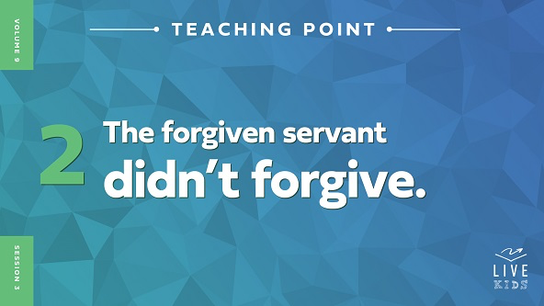

• *Read* [*Matthew 18:23–29*](https://ref.ly/logosref/Bible.Mt18.23-29)*.*

Jesus started His story about a man who owed a lot of money to a king. The man had a problem.

• *Ask a volunteer to hold up a* ***Teaching Time Sign****.*

When it was time for the servant to pay his debt, he couldn’t do it. Why not? *(Allow responses.)* The king wanted to collect the money that was fairly owed to him. Since the man didn’t have enough money to pay, the king was ready to take desperate measures and have the man and his family sold to pay the debt. The man begged the king not to do this, and amazingly, the king showed mercy to the man and canceled his debt entirely. The man didn’t have a problem anymore.

• *Tear up the sign and throw it up in the air like confetti.*

How would you react if you were the forgiven man? *(Group response)* An impossible debt was paid off. That sounds like a pretty amazing gift that would be life changing. But, when the man left the king, he saw someone who owed him a smaller amount of money.

• *Invite a second volunteer to hold a* ***Teaching Time Sign****.*

• *Encourage the volunteers to act out what you say.*

This man had the same problem. He didn’t have the money. He began begging for mercy. Sound familiar? *(Group response*) Now, the forgiven man had an opportunity. He could either choose to hold on to his problem with the other man who owed him money, or he could release that problem and show mercy like he had received. What should he have done? *(Allow responses.)*

It’s easy to see what others should do in situations like this. We all get opportunities to forgive others because bad things happen to all of us. They can hurt a lot, way more than someone owing us some money. We can be bullied, betrayed, hurt, or many other things. After those things happen and we ask God for help, we have a choice to make just like the forgiven man did. We can let go of the problems and forgive, or we can keep holding a grudge. Let’s see what the Bible says about what the forgiven man did.

**3. The forgiven man was “un-forgiven.”**

*Show the* ***Teaching Point 3 Slide.***

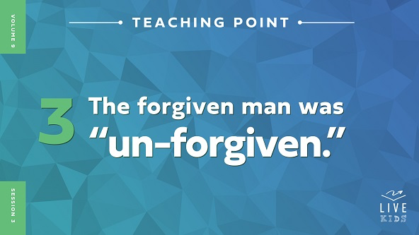

• *Read* [*Matthew 18:30–35*](https://ref.ly/logosref/Bible.Mt18.30-35)*.*

That can’t have just happened! Did the forgiven man extend forgiveness to the one who owed him a smaller amount of money? *(Group response)* No, he punished the man who owed him money.

• *Have the second volunteer kneel on the floor and bow his head while holding the sign.*

Then, the king found out! The king was very upset because the forgiven man didn’t show the same mercy he had been shown.

• *Give another* ***Teaching Time Sign*** *to the first volunteer and have him kneel down with his head bowed.*

The forgiven man wouldn’t let go of the problem he had with the other servant. Even though he had been shown extreme mercy by the king, his unwillingness to forgive led him to being thrown into prison where he would stay until all his debt was paid.

Jesus always had a good reason for telling parables. I think Jesus wanted us to understand that God is like the king and that we are like the servants. We all have sinned against God even though He is the Creator of the universe. That’s a big deal! Because of our sin, we can’t fix our relationship with Him without His forgiveness. Jesus paid for that debt and cancelled it so we could get that forgiveness. What an incredible gift!

Even after receiving that gift, we can still be like the man in the story. We can get upset at other people for much smaller problems. Wouldn’t it make sense for us to be willing to forgive others after we have been forgiven for so much? *(Group response)*

• *Have the volunteers return to their seats.*

Now, it’s important you know that forgiveness doesn’t mean that the wrong things someone did to you are okay. Remember, forgiveness is letting go of bitterness or anger toward a person on the inside and not holding what they did against them

anymore. It doesn’t always mean that the person who hurt you has to be your friend again. Talk to an adult if you are in a situation like that. God wants us to remember how much we have been forgiven and for us to share that forgiveness with others. This shows His love and keeps us from holding burdens He doesn’t want us to try to handle on our own.

**Prayer and Response**

*Consider playing a worship song softly in the background while kids pray.*

Forgiving someone is a powerful way to show God’s love, and it’s what the king expected the man to do after his huge debt was forgiven. If we want to live God’s best for our life, we must let go of unforgiveness and trust God to take care of those situations.

Today, I want to give an opportunity for you to forgive anyone you might be holding something against. Sometimes, the first step to forgiving someone is asking God to help you do it and telling Him that you know you need to forgive them. I want everyone to think of a situation where you need to forgive someone. Once you have it in your mind, we’ll pray together.

• *Give kids time to pray on their own. Then, pray together.*

**Prayer**

*Optional: Have the kids repeat phrases of the prayer after you.*

|  |
| --- |
| Dear God, thank You for forgiving me. Please help me to forgive ______. God, that person hurt me a lot, but I want to be obedient to You. God, help them experience Your love and mercy just like I have. Amen. |

I’m so proud of you! God loves you so much, and He wants you to know the freedom that comes from forgiving others. He will be with you always, and He will help you forgive others.

**Faith Verse**

Our Faith Verse reminds us that when we follow Jesus, He changes us for the better. Forgiving others is one of the ways He does that. Nothing in our life should keep us away from Him.

• *Play* ***Faith Verse Video****.*



[2 Corinthians 5:17](https://ref.ly/logosref/Bible.2Co5.17) (NLT)

Anyone who belongs to Christ has become a new person. The old life is gone; a new life has begun!

Let’s say that verse together all at once. *(Group response.)* Great work.

**Faith Fact**

Before we go to our small groups, let’s review our Faith Fact again. **I can forgive others.**

• *Show the* ***Faith Fact Slide****.*



Let’s say that Faith Fact together. **I can forgive others.** Point at yourself and then at everyone in the room while saying it. **I can forgive others.**

• *Dismiss kids to Small Group time or to go home if your group time ends here.*

**Small Group**

**30 Minutes**

*This section can be done in conjunction with the large group or on its own if you do small groups with your kids. During Small Group time, the goal is to connect the kids with the Word of God and to each other. All activities are led by the small group leader.*

**Group Connection**

**Let it Go**

|  |
| --- |
| ***You Will Need***   * *Small coins, one per kid* * *Cups, one per group*   *No prep needed for this activity.* |

In our story, Jesus told Peter about the importance of forgiveness. Forgiveness is letting go of bitterness, anger, or bad feelings we feel toward those who have hurt us. Let’s talk more about that. Today, everyone will get something to hold.

• *Hand out the coins and place the cup in the middle of the group.*

Now, hold onto this coin so tightly that we can’t see it in your hand *(demonstrate)*. When we don’t forgive, that’s what we do with the hurt. We keep holding on tight. Is your hand getting tired yet? *(Group response)*

Unforgiveness can be like that. Other people might not be able to see it inside us, but we know when someone has hurt us so badly that we can’t forget about it. In those times, Jesus wants us to talk to Him about forgiveness. Open up your hand *(demonstrate)*.

Jesus can help us to forgive. When He does, He helps the pain from the situation go away. When you’re ready, drop what you’re holding into the cup as a sign that you want to forgive others because you’ve been forgiven. As you drop the coin, say the Faith Fact. **I can forgive others.**

• *Give kids time to respond.*

**Bible Lesson Recap**

• *If small group activities are not immediately following large group time, you may want to read the Bible story passage before the discussion.*

|  |
| --- |
| ***You Will Need***   * *Bibles for kids in the group to share*   *No prep needed for this activity.* |

**Bible Story Review: The Parable of the Unmerciful Servant** [**Matthew 18:21–35**](https://ref.ly/logosref/Bible.Mt18.21-35)

What was the most interesting about today’s Bible story? *(Allow responses.)* Those are great answers! To review, Jesus told a parable about a man who was forgiven a huge debt by the king. Then, the man wouldn’t forgive someone who owed him a much smaller debt. Jesus wants us to know that forgiving others is really important!

Why should we forgive others? *(Allow responses.)* One important reason is that forgiving others shows God’s love to them and helps us let go of burdens God doesn’t want us to carry.

• *Give each kid a Bible and read the Bible story together.*

**Group Discussion**

*Feel free to use all or just a few questions as a jumping-off place for good discussion. Questions marked with * are designed for more conversation. Adjust the questions based on the age or maturity of your group. Typically, older kids will be able to dive a little deeper than younger ones.*

**Questions**

What question did Peter ask Jesus?

Why do you think Peter asked this question?

How did Jesus answer Peter? What did He mean by this?

* What happened in the parable Jesus told?

Who is like the man in the story? Who is like the king in the story?

* Have you ever been forgiven for something you did that was a big deal?

* Why is it important to show God’s forgiveness to others?

**Live It**

**Faith Fact**

Our Faith Fact is **I can forgive others.** Jesus showed us that it’s important to forgive others. God has forgiven us for doing many wrongs, and we don’t deserve His forgiveness. We should do the same for other people.

**Challenge**

The challenge for this week is to write a prayer asking God to help you forgive someone who has wronged you. Whether it’s a friend, a family member, or someone you aren’t around anymore, give your hurts to God and let go of them through forgiveness.

**Prayer**

*Finish group discussion by sharing prayer requests and praise reports. Keep track of your small group’s prayer requests and review them each time you meet.*

• *Have kids share and pray for each other’s prayer requests.*

|  |
| --- |
| *Dear God, thank You for hearing us when we pray. Please help us to forgive others. You have forgiven us of so much, and we just want to be like You. Give us the strength to let go of hurts from hard situations. In Jesus’ name. Amen.* |

**Faith Verse Review**

|  |
| --- |
| ***You Will Need***   * ***Small Group Faith Verse Review****, one set per team* * *Envelopes, one per team* * *Scissors* * *Optional: Smartphone with stopwatch*   ***Getting Ready***   * *Print the* ***Small Group Faith Verse Review****, one set per team.* * *Cut apart the page into ten random shapes to create ten puzzle pieces.* * *Place the puzzle pieces for each team in an envelope.* |

Our Faith Verse is [2 Corinthians 5:17](https://ref.ly/logosref/Bible.2Co5.17). Jesus makes our lives brand-new. Let’s go over the Faith Verse together.

• *Show* ***Faith Verse Video****.*



[2 Corinthians 5:17](https://ref.ly/logosref/Bible.2Co5.17) (NLT)

Anyone who belongs to Christ has become a new person. The old life is gone; a new life has begun!

Following Jesus means that we get a fresh start in our life. The old parts of us aren’t who we are anymore. God makes us new. Let’s review our Faith Verse as you try to memorize it as best as you can. We will need to know it for the Faith Verse game.

• *Say the verse as a group a couple of times.*

**Faith Verse Fun**

**Verse Puzzle**

All right, it’s time to put our knowledge of the Faith Verse to the test. Your goal is to work together to assemble the puzzle to show our Faith Verse. Let’s see how fast you can do it!

• *Play the game. Consider having two teams race against the clock and see if they can beat the previous record.*

• *Optional: Add a relay. Have kids go, pick up their puzzle pieces, and bring them to another area to assemble the verse.*

Great job, everyone! Memorizing this Faith Verse will help you choose to live your new life for Jesus.

**Activity Page**

**Comic Strip Draw**

|  |
| --- |
| ***You Will Need***   * ***Small Group Activity Page****, one per kid* * *Pencils, one per kid* * *Crayons*   ***Getting Ready***   * *Print the* ***Small Group Activity Page****, one per kid.* |

Our Faith Fact is **I can forgive others.** We don’t want anything in the way of God’s best for our life.

• *Hand out a copy of the* ***Small Group Activity Page****, a pencil, and crayons to each kid.*

We talked earlier about forgiving someone who had hurt us. Today’s activity is to write words for a comic about forgiving someone else. I’m excited to see what you come up with!

• *Give kids time to complete the activity.*

• *Invite them to share their comic strip with the group when they’re finished.*

**Dismissal**

Remember that God wants us to honor Him. It’s not just so we follow His rules or do what He says. God knows that our life is the best it can be when we listen to and obey Him.

**Prayer**

|  |
| --- |
| *Dear God, please help us to accept the love You have for us. We want to show forgiveness to others as You have shown forgiveness to us. Help us to trust You to do this even when it’s hard. We want to show Your love to others. In Jesus’ name. Amen.* |

**Faith Fact Recap**

• *Show the* ***Faith Fact Slide****.*



Remember that God wants us to help us let go of unforgiveness! He wants to be close to us. Our Faith Fact can help us remember that. **I can forgive others.** I’m so glad you came today. I can’t wait to see you next time**.**

• *Send home the* ***Small Group Activity Page.***

• *Remind parents that there are* ***Family Devotions*** *available on the app to do with their kid.*

• *Tell everyone the date and time for the next session.*